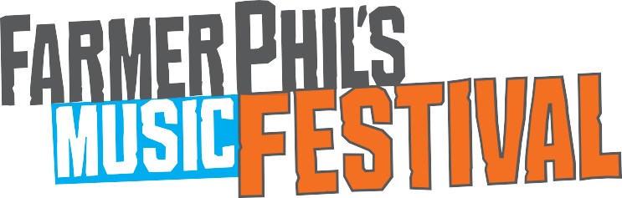
Near Gatten Farm, Ratlinghope, Shropshire SY5 0SN
11 - 13 August 2023

Name: |  |  | D.O.B:
Address:
E-mail:
Telephone: | Date of arrival & approx. time:
Next of kin / emergency contact: Telephone:
Please indicate in which areas you would be willing to work in order of preference, where No. 1 is your most preferred. Please mark an ‘SL’ if you would be interested in a Shift Leader role and submit a CV with your application:
Do you have a first aid certificate? YES NO |  | Are you DBS checked? YES NO
Please list events and areas of work you have had previous experience of working at a festival or similar event:
Do you have any health problems or other special requirements of which the organisers should be aware? If
yes, please state:
Please state briefly why you would like to volunteer and why you feel you are a suitable candidate:
Please indicate if there is a specific band(s) you would like to see or time you would like to have off-duty. This is
not guaranteed but we will make efforts to accommodate this where possible.
Please indicate if you would prefer to be shifted at the same time as another steward (i.e. spouse/partner, sibling, friend etc), stating their name.
Where did you hear about volunteering at Farmer Phil’s Festival?
I have read and agreed to abide by the festival volunteer terms and conditions.

Signed: Date:

Near Gatten Farm, Ratlinghope, Shropshire SY5 0SN
11 - 13 August 2023

Being part of the Farmer Phil’s Festival crew is huge fun. You’ll be worked hard but your hard graft will be rewarded with an unforgettable weekend of fun and satisfaction. The festival is great because you are great so we have high expectations. Come! Join the fold...

How to Apply

Read the terms and conditions thoroughly, you must be prepared to adhere to these, if not then volunteering may not be for you.

Complete the application form with full contact details, including telephone number and email address, plus copies of your proof of ID for
UK citizenship, and return to Farmer Phil’s Festival ASAP. We are most likely to contact you by email so please check your account regularly.

Festival Volunteer Terms and Conditions

- All volunteers will need to pay an upfront FULLY REFUNDABLE deposit of £40. This will be REFUNDED once your allocated shifts
have been completed at the end of the festival. If your application is successful, we will contact you with acceptable payment methods.

- All volunteers for bar, stewarding, customer service roles must be 18 years old or over, or for sales or litter picking must be 17 years
old or over, on the first day they arrive at the festival.

- All volunteers must register at the Bar between the hours of 6pm and 8pm on Thursday 10 August 2023.

- You will be required to present proof of your UK citizenship (i.e., right to work) on arrival at your training session. This should be the
proof, of which you have supplied copies to Farmer Phil’s Festival, in your application. This can be provided in the form of:

  - EU passport, or

  - birth certificate, or

  - national insurance number card with a P60 or P45
[a driving license, even for the UK, is NOT adequate]

If you have another means of proof that you would like to check is suitable please email fpfstewards@gmail.com to verify.

- All volunteers will work a minimum of 12 hours throughout the festival (please state if you are happy to do more hours). Most shifts (3 x 4 hours) are between 12pm on Thursday 10 August 2023 and 2am early on Monday 14 August 2023, (if you are happy to come earlier in the week please let us know, benefits of this will be you won’t have to do as much over the weekend itself).
- Your priority as a volunteer is to help us run Farmer Phil’s Festival. We appreciate that there may be specific attractions at the festival
that you may want to see, and although we will try to be accommodating where possible, it may be that requests cannot be met.

- If you are accepted, you will receive acceptance notification once we have processed your form.

- If you are not successful, Farmer Phil’s Festival will inform you within 20 days of your application.

- You will receive further information regarding the shifts you will work and your festival duties after 31 July 2023. Though we will make every effort to notify you of shift changes in good time, occasionally alterations to the volunteer rotas can occur up to and on the day of your shift. You will be expected to attend a different shift if required to do so. Farmer Phil’s Festival will make every effort to honour your shifts as originally notified.
- Failure to attend an assigned shift or attendance in an intoxicated state will result in your fee been withheld and a refund no longer available.

